R-Shiny App Sketch

Salomon Villatoro

4/1/2021

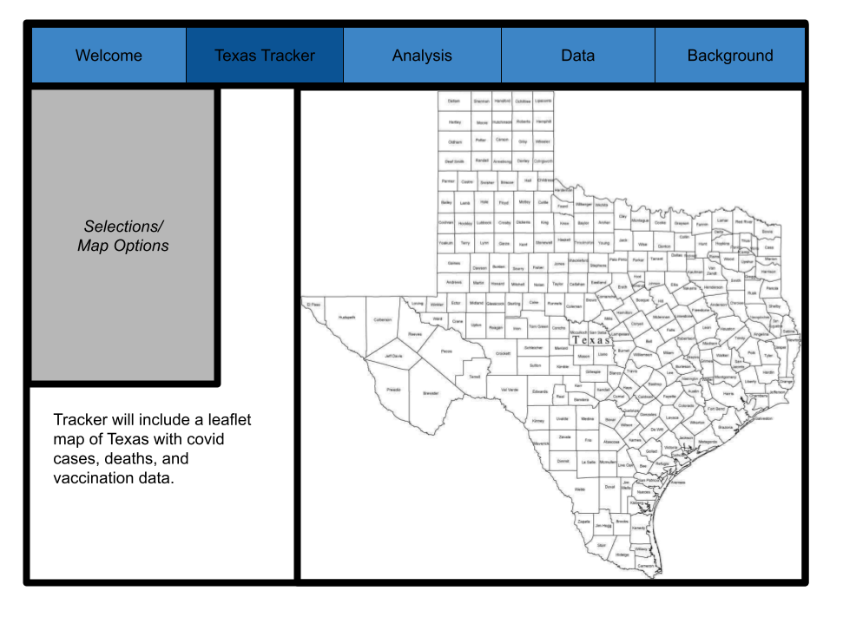

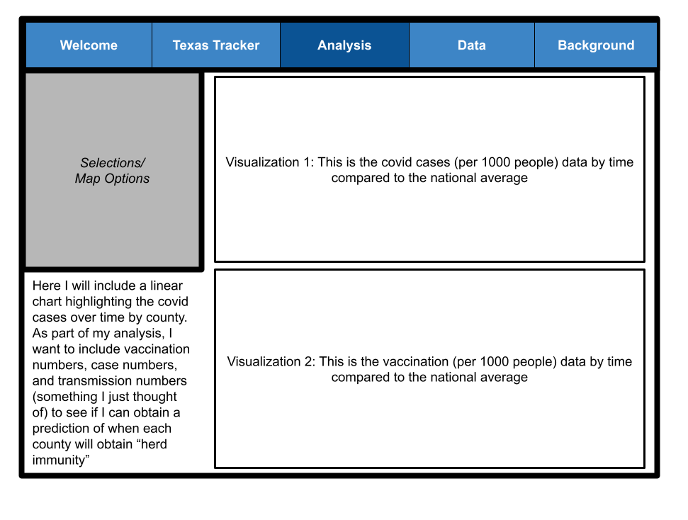Analysis tab will have visualizations as line charts using ggplot2 where you can filter information by county with a similar line following state numbers and national numbers. (I may use a third analysis tab).

Data Tab - will include explanations of the data I used and why it was chosen.

Background Tab - will include reasons for using this data, why covid is important, and a discussion section on the findings of the transmission, herd immunity analysis.